7-DieOut

This module determines when and the rate a upper canopy layer in a cohort will die out. The rational is that the upper canopy layer has a finite life-span and has a limited ability to expand horizontally after a certain age. Therefore after a certain age mortality and disturbance will decrease the area the upper tree layer can occupy. When the area occupied by the upper tree layer decreases, the light reaching the lower tree layer increases (Figure 7-1). The parameters used to define when trees die out (AgeMax, TimeClose, TimeCloseWindow) are contained within the Mort.prm file.

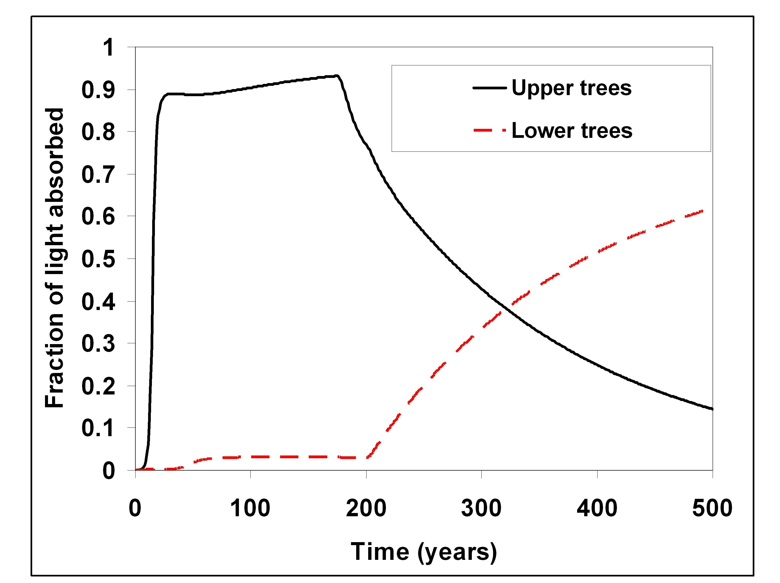

Figure 7-1. Example of how the DIEOUT model removes upper trees once TimeClose has been reached for a species. At TimeClose the horizontal spread of individual trees reaches a maximum and therefore mortality leaves openings for lower trees to receive more light.

TimeThere Function.

This function calculates the time the upper tree layer has occupied a cohort. Because not all the trees are planted in simulation year 0, there is a difference between the simulation time and the time a tree species occupies a cohort. To determine if an upper canopy layer has a chance of dying out, the time the species is present in the cohort must be calculated:

TimeThere=Time-TimePlant

where time is the simulation Time in years, TimePlant is the simulation time that an upper tree species was planted in a cohort, and TimeThere is the number of years an upper species has occupied the upper canopy layer of a cohort.

DieOut Function.

This function calculates the rate an upper tree layer dies out, freeing up space and light for the lower tree layer. The area occupied by an upper tree layer is a function of the time the species has occupied a cell. If the time since a species was planted in a cell (TimeThere) is less than TimeClose (defined in the Mort.prm file) then :

UpperTreeArea= 1.0

If the time since a species was planted in a cell (TimeThere) is greater than or equal to TimeClose, then the area occupied by the upper tree layer decreases as follows:

UpperTreeArea= exp[-ExtRate*(Time-TimeClose-TimeCloseWindow)]

where ExtRate is the annual probability that a species will die, and TimeClose Window is the period of time it takes for all upper trees to reach their maximum horizontal extent once TimeClose is reached. The rate upper trees decline is calculated from the maximum age of the species (AgeMax) and the time required for a single tree to dominate a plot (TimeClose):

ExtRate=4.61/(AgeMax-TimeClose)

As upper trees lose area, they receive less light and this limits their growth. Light not used by the upper tree layers is passed to the lower tree layer and as that light increases the upper trees become more and more dominant.

It should be noted that once upper tree pass the time they can not expand horizontally, other forms of mortality such as harvest and fire will also cause the upper tree layer to lose area.

